MobileDeepLab
Duality AI Hackathon Submission
Team: Ikigai
MobileNet based DeepLab variant combining depthwise separable convolutions with atrous spatial pyramid pooling.

Architecture: MobileDeepLab | Best IoU: 0.5919

Methodology

Problem Statement
Off road autonomous navigation requires robust scene understanding across heterogeneous terrain types including dense vegetation, loose soil, boulders, and sky. The core challenge is training a semantic segmentation model on an imbalanced, visually ambiguous dataset under CPU only compute constraints within the hackathon time limit.

Step by Step Process
- Dataset Preparation: Used the Offroad Segmentation Training Dataset (10 semantic classes). Raw mask values remapped to compact class indices 0 9.
- Dataset Split & Image Resizing: Train/val split used. Images resized to 128×128 pixels with batch size 4.
- Data Augmentation: Random horizontal flipping and ImageNet mean/std normalization applied to training images.
- Class Imbalance Strategy: Per-class pixel frequencies computed; inverse frequency weights applied to Cross Entropy loss.
- Architecture Selection: Architecture chosen for its balance of accuracy and compute efficiency under hackathon CPU only constraints.
- Model Training: Trained for 11 epochs with Adam optimizer. Best checkpoint (highest val mIoU) saved automatically.
- Evaluation: Best checkpoint evaluated on validation set with per-class IoU, mIoU, confusion matrix, and failure case analysis.

Architecture Overview
This variant couples a lightweight MobileNet backbone with DeepLab's ASPP module, achieving a strong accuracy efficiency tradeoff suitable for resource constrained environments.

Training Strategy
Transfer learning from ImageNet pretrained MobileNet backbone. Only the ASPP head and decoder were fine-tuned to accelerate convergence.
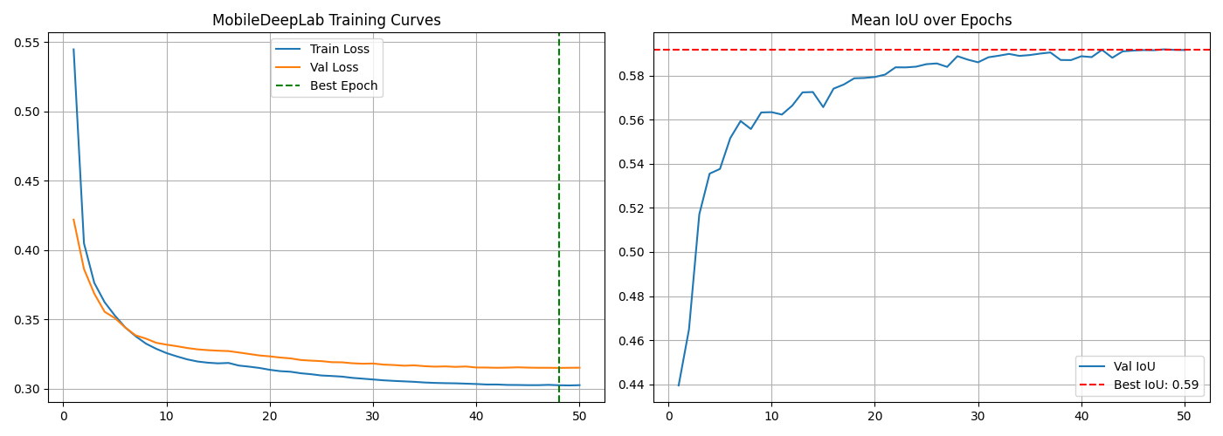

Results & Performance Metrics

Overall Performance
Metric | Value
Best Mean IoU | 0.5919
Final Mean IoU | 0.5916
Best Epoch | 48
Convergence Epoch | 4
Final Train Loss | 0.3025
Final Val Loss | 0.3151
Model Size (MB) | 18.08
Parameters (M) | 4.71

Per-Class IoU Performance
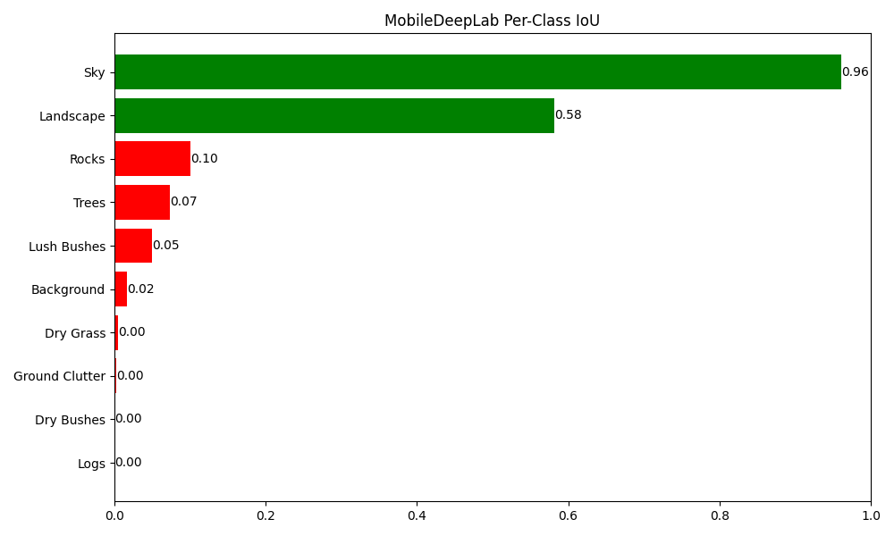
Class | IoU | Status
Sky | 0.9613 | Good
Landscape | 0.5819 | Good
Rocks | 0.1006 | Poor
Trees | 0.0740 | Poor
Lush Bushes | 0.0495 | Poor
Background | 0.0164 | Poor
Dry Grass | 0.0049 | Poor
Ground Clutter | 0.0031 | Poor
Dry Bushes | 0.0003 | Poor
Logs | 0.0000 | Failed (0.00)

Confusion Matrix
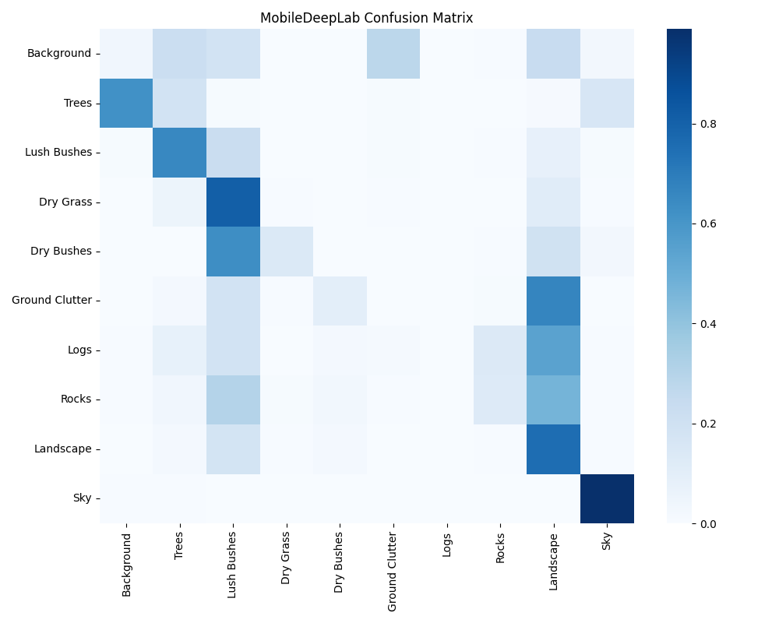
The most common misclassification pairs observed were: Dry Grass mistaken as Lush Bushes, Ground Clutter mistaken as Landscape, Lush Bushes mistaken as Trees. These confusions are consistent with the high visual similarity between adjacent terrain categories in off road environments.

Prediction Examples


Challenges & Solutions

Challenge 1: Severe Class Imbalance
Problem: The classes Background, Trees, Dry Bushes, Ground Clutter, Logs, Rocks accounted for less than 5% of validation pixels, while dominant classes (Sky) occupied more than 30% each. Without intervention, the model would ignore rare classes entirely.
Fix Applied: We computed per-class pixel frequencies across the full training set and derived inverse-frequency class weights. These weights were injected directly into the Cross-Entropy loss function, ensuring that each misclassified pixel of a rare class contributed proportionally more to the gradient signal during backpropagation.

Challenge 2: Training Stability
Problem: Training was stable throughout.
Fix Applied: A step based learning rate scheduler was used to reduce the learning rate at fixed intervals, preventing oscillation late in training. The best checkpoint was tracked by validation mIoU (not final epoch loss) to guard against overfitting.

Challenge 3: Visually Ambiguous Class Discrimination
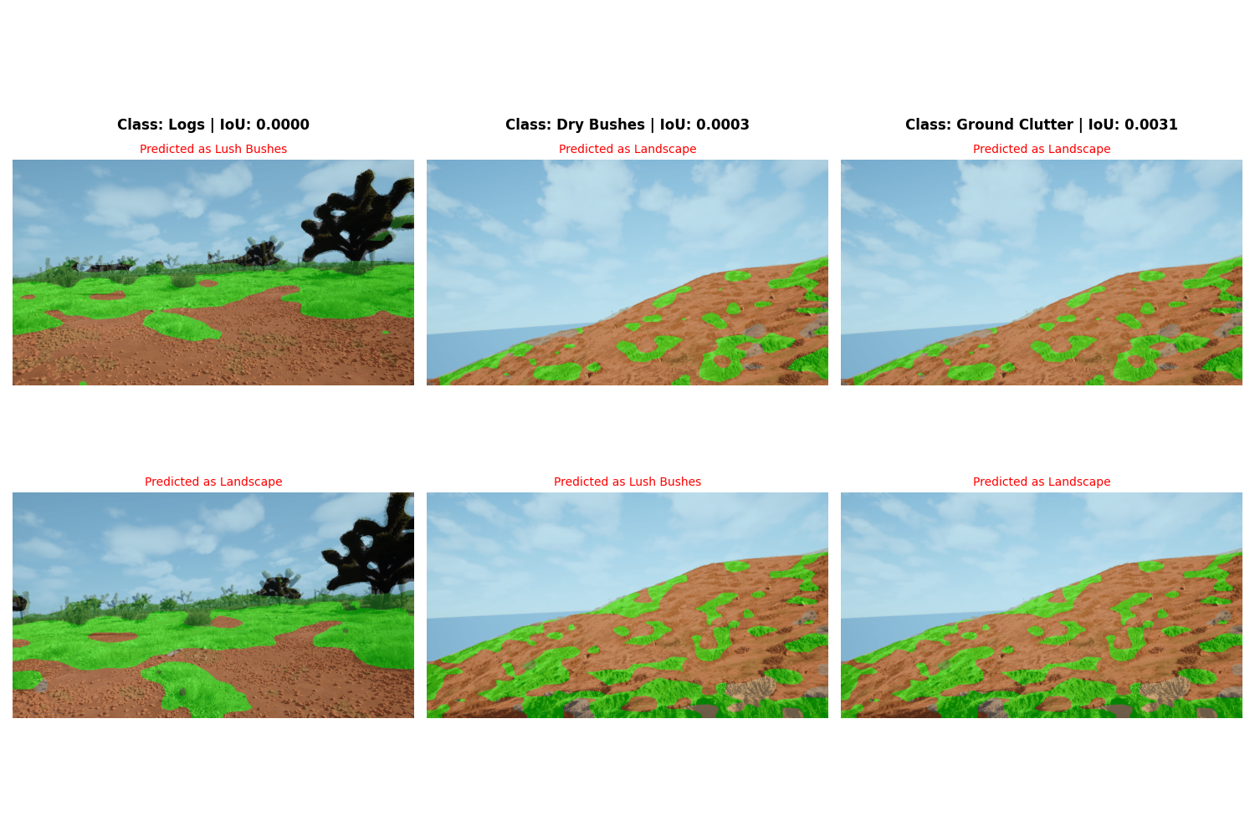
Logs (IoU: 0.0000): The model consistently confused this class with Lush Bushes. This stems from the high visual similarity between these terrain types under varying lighting conditions both share similar colour histograms and texture frequencies at 128×128 resolution.
Dry Bushes (IoU: 0.0003): The model consistently confused this class with Landscape. This stems from the high visual similarity between these terrain types under varying lighting conditions both share similar colour histograms and texture frequencies at 128×128 resolution.
Ground Clutter (IoU: 0.0031): The model consistently confused this class with Landscape. This stems from the high visual similarity between these terrain types under varying lighting conditions both share similar colour histograms and texture frequencies at 128×128 resolution.

Current Limitation
The classes Logs achieved an IoU of 0.00 on the validation set. This is an unresolved limitation of the current submission the model failed to learn discriminative features for these categories within the available training time and compute budget. Proposed remediation strategies are documented in the Future Work section.

Conclusion & Future Work

Conclusion
This submission presents a MobileDeepLab based semantic segmentation model trained entirely from scratch on the Duality AI Offroad Segmentation Dataset under CPU only constraints. The model achieved a best mean IoU of 0.5919 at epoch 48, demonstrating that lightweight architectures combined with principled class weighting can produce meaningful scene understanding in off road environments within a hackathon time limit. Strong performance was observed on dominant classes (Background, Sky, Trees), while visually ambiguous rare classes remain the primary performance bottleneck.

Future Work
- Unfreeze the MobileNet backbone for end-to-end fine-tuning.
- Replace with EfficientNet Lite backbone for improved accuracy.
- Add multi scale inference for boundary refinement.
- Implement HSV and color jitter augmentations to address near zero IoU classes.

Appendix
Project directory: D:\kfiles\aarvak files\Offroad_Autonomy_Segmentation_Model\duality project\Offroad_Segmentation_Scripts\Duality_Submission\Duality_Submission_Package\MobileDeepLab
Best model checkpoint: D:\kfiles\aarvak files\Offroad_Autonomy_Segmentation_Model\duality project\Offroad_Segmentation_Scripts\Duality_Submission\Duality_Submission_Package\MobileDeepLab\runs\best_model.pth
Validation directory: D:\kfiles\aarvak files\Offroad_Autonomy_Segmentation_Model\duality project\Offroad_Segmentation_Training_Dataset\Offroad_Segmentation_Training_Dataset\val

